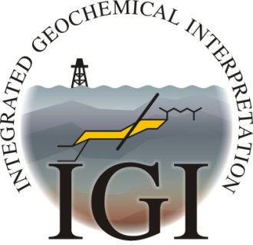
COURSE BOOKING FORM
Integrated Geochemical Interpretation Ltd.
The Granary, Hallsannery, Bideford, Devon, EX39 5HE, UK.

Tel: +44 (0) 1237 471749, Fax: +44 (0) 1237 421700
E-mail: info@igiltd.com
Website: www.igiltd.com

2, 3 or 5 day Petroleum Geochemistry and/or Basin Modelling training course
Monday 19 – Friday 23 October 2015 at the
(Thistle Holborn) The Kingsley Hotel, London, UK

NAME:

COMPANY:

ADDRESS:

TEL:

TEL (Mobile):

Email:

Any special requirements:

Please indicate which course(s) you wish to attend:
2-day course Introduction to Petroleum Geochemistry 19 -20 October

Followed by the option to attend either:
1. 3-day course in Petroleum Systems Basin Modelling 21 - 23 October

or
2. 3-day course in Advanced Petroleum Geochemistry 21 - 23 October

The cost for the full 5-day training course is £2,600 + VAT
The cost for the 2-day introduction to geochemistry training course is £1200 + VAT
The cost for the 3-day petroleum systems basin modelling course is £1800.00+VAT
The cost for the 3-day advanced geochemistry training course is £1800 + VAT
These prices include tuition, course notes and lunches
Please note: IGI Ltd. does not accept Credit Card Payments

Please return this form to:
Helen Davis, IGI Ltd., Hallsannery, Bideford, Devon EX39 5HE, UK.
Tel: +44(0) 1237 471749; Fax: +44(0) 1237 421700; email: helendavis@igiltd.com



